Roundup list post template
Meta title 58/60  Character limit: 60 | 12 Best Automatic Pool Cleaners in South Africa | Baracuda
Meta description  Character limit: 119/140 | Find the best automatic pool cleaners in South Africa. We compare their features, price points & more. Read on Baracuda
Focus keyphrase | best automatic pool cleaner south africa
Surfer credit | Attach a SurferSEO Content Editor credit to the document.
Suggested URL (/60) | /blog/best-automatic-pool-cleaners-south-africa  Refer to the SEO content creation fundamentals document if you are unsure
Keyword research sheet link | Baracuda Blog Topics - new content  best + pool cleaners, pumps, heat pumps, lights - template
Full research document | Research Doc - Automatic Pool Cleaners - Baracuda
Images | Images
Title and introduction

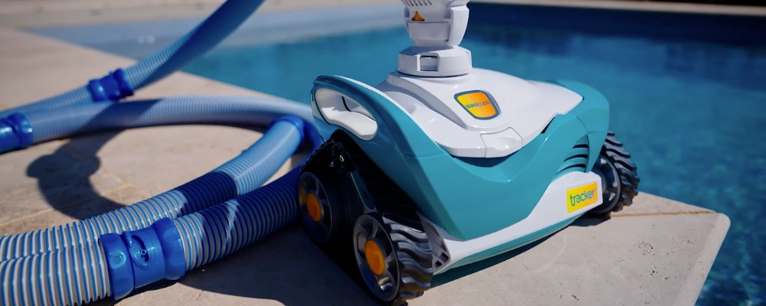

H1: 12 Best Automatic Pool Cleaners in South Africa (Residential Pools)

Choosing the right automatic swimming pool cleaning system will help you make pool maintenance easier and more efficient.

This article explores some of the best pool cleaners for residential pools available in South Africa, including powerful robotic cleaners and suction pool cleaners.

We compare each cleaner’s coverage, surface compatibility, features, pricing, and where you can purchase them.

Whether you own a small plunge pool or a larger family-sized pool, you’ll find options to suit your cleaning needs and budget.

Read on to find out more. If you need expert advice, contact us or use our interactive map to find a pool store that stocks Baracuda products near you. You can also explore our range of automatic pool cleaners.

Key takeaways
Key takeaways

- Choosing the right automatic pool cleaner depends on your pool’s size, surface type, debris load, and whether you want a low-maintenance solution or advanced automation.
- Top robotic models include the Baracuda XA4030 iQ and Zodiac ALPHA RA6700iQ—offering app control, wall and waterline coverage, and premium filtration.
- Leading suction cleaners include the Zodiac AX20 Activ, Baracuda Tracker, and Gemini—ideal for basic floor and wall cleaning at a more budget-friendly price point.

Optional value-add section

* H2: How much does an automatic pool cleaner cost in South Africa?
The cost of an automatic pool cleaner in South Africa varies widely depending on whether it is a suction pool cleaner or a robotic pool cleaner, as well as the brand, model and the features it offers.
Suction pool cleaners can cost anywhere from R1300 to R5000.
More budget-friendly options like Baracuda Ranger, Gemini and BLU52 Navigator can retail between R1300 and R2600. These models typically have more basic functionalities, including randomised cleaning patterns, floor-only coverage, and single-diaphragm suction systems.
Options like the Baracuda Tracker or Zodiac AX20 with more advanced capabilities, such as geared navigation, wall-climbing performance, and dual scrubbers or diaphragms, can retail from R3000 to R5000.
Robotic pool cleaners typically cost between R13,000 and R26,000.
More basic, budget-friendly options like the Baracuda XA2030 can retail for between R13,000 and R15,500. These models generally offer floor and partial wall coverage, plug-and-play operation, and standard filtration systems. Premium models like the Baracuda XA4030 iQ, and the Zodiac ALPHA RA6700iQ, with more advanced capabilities such as smart navigation, app control, and full pool coverage, including the waterline, can cost between R18,000 and R26,000.
Prices may vary per retailer, but these ranges provide a benchmark for South African pool owners.
However, don’t focus solely on the initial purchase price.
Consider ongoing expenses, such as energy consumption, replacement parts, and maintenance requirements, when planning your pool cleaner budget.
Investing in a quality swimming pool cleaner upfront typically saves both time and money on pool maintenance over the years, making it a smart long-term decision for most pool owners.
In a related article, we cover how to choose an automatic pool cleaner based on your budget and cleaning needs.

Table of contents
H1: 12 Best Automatic Pool Cleaners in South Africa (Residential Pools)
* H2: How much does an automatic pool cleaner cost in South Africa?
H2: Best Robotic Pool Cleaners in South Africa
H3: 1. Baracuda XA4030 iQ - Premium robotic cleaner with intelligent navigation and full pool coverage
H3: 2. Baracuda XA2030 - Smart, efficient robotic cleaner for floors and walls
H3: 3. Zodiac RE4600iQ – Premium robotic cleaner with full coverage and smart control
H3: 4. ALPHA RA6700iQ – Advanced robotic cleaner with precision control and waterline scrubbing
H3: 5. Aiper Scuba S1 – Cordless robotic cleaner with smart navigation and dual-drain design
H3: 6. Dolphin S100 – Reliable entry-level robotic cleaner for smaller pools
H2: Best Suction Pool Cleaners in South Africa
H3: 7. Baracuda Ranger – Simple, affordable suction cleaner for everyday use
H3: 8. Baracuda Tracker – Advanced suction cleaner with smart navigation and wall coverage
H3: 9. Zodiac Pacer - Classic suction cleaner built for simple, reliable floor cleaning
H3: 10. Gemini Pool Cleaner - Twin-diaphragm suction cleaner for powerful and consistent performance
H3: 11. Zodiac AX20 Activ - Suction cleaner with geared navigation and active scrubbing
H3: 12. Kreepy Krauly Bullshark Pro – Budget-friendly suction cleaner with durable diaphragm design
* H2: What is the best pool cleaner in South Africa?
H2: Final Thoughts on The Best Automatic Pool Cleaners in South Africa

Category 1

H2: Best Robotic Pool Cleaners in South Africa
Robotic pool cleaners offer the ultimate convenience, power, and intelligent cleaning.

Unlike suction models, they operate independently from your pool’s pump, using built-in motors, smart navigation, and advanced filtration to deliver thorough results with minimal effort.

In this section, we’ve compared some of the best robotic pool cleaners available in South Africa, ranging from high-end, app-controlled units with waterline scrubbing to compact, budget-friendly models ideal for smaller pools.

Whether you’re after deep cleaning performance or set-and-forget simplicity, these top-rated options cater to various pool sizes, surfaces, and budgets.
Linkreators - 1-6

H3: 1. Baracuda XA4030 iQ - High-end robotic cleaner with full pool coverage and app control
The Baracuda XA4030 iQ is a premium robotic pool cleaner designed for powerful, intelligent cleaning of large residential pools with minimal effort.

H4: Coverage and Pool Compatibility
This model is designed to clean pool floors, walls, and the waterline. It is suitable for in-ground pools up to 12 × 6 m, featuring an 18m cable. It is suitable for cleaning most pool shapes and any type of pool surface, including tiled and fibreglass pools.

H4: Filtration and Debris Handling
The XA4030 iQ features a progressive 150/60-micron dual-level filtration system with an illuminated top-access canister. The device captures fine particles and larger debris, like leaves and twigs.

H4: Key Features and Functionality
- SmartNav system with gyroscopic sensor for efficient pathing
- App control via iAquaLink™ for scheduling cleaning cycles and remote control operation
- Powerful dual-motor with active brushing
- Patented lift system that makes removing the device from the pool easy
- Energy-efficient operation with programmable cycle times

H4: Price Range and Warranty
This cleaner model is typically priced between R18,000 and R21,000 in South Africa, with a 2-year warranty, including a 1-year warranty on wearable parts, including the filter canister, tracks, and roller brush.

H4: Where to buy
Use our interactive map to find a pool store that stocks Baracuda products near you. You can also buy the Baracuda XA4030 on Takealot.
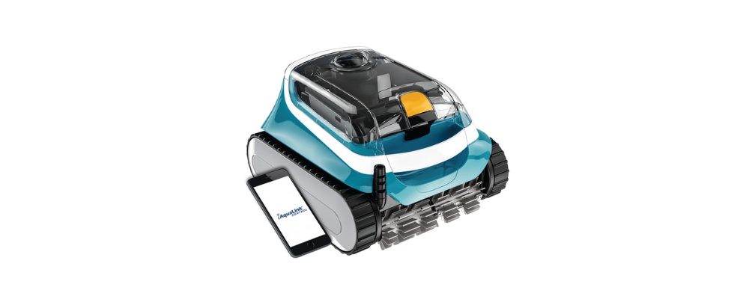

H3: 2. Baracuda XA2030 - Smart, efficient robotic cleaner for floors and walls
The XA2030 is a mid-range robotic pool cleaner that offers intelligent navigation, reliable wall coverage, and active scrubbing for clearing stubborn debris.

H4: Coverage and Pool Compatibility
This model is designed to clean pool floors and walls, but not the waterline. It is ideal for in-ground pools up to 10 × 5 m featuring a 15m cable. It is compatible with pools of most shapes and all surfaces, including marbelite, fibreglass, and vinyl.

H4: Filtration and Debris Handling
The XA2030 features progressive filtration with a standard 100-micron filter for trapping dirt and debris and an optional finer canister for catching extra-small particles. It also features an illuminated top-access filter chamber. The transparent lid makes it easy to monitor and clean.

H4: Key Features and Functionality
- Intelligent navigation system for route optimisation
- Dual-drive motor enables effective climbing and turning
- Active scrubbing brushes tackle stubborn dirt
- Quick-clean cycle with automatic shut-off
- Easy Lift System for hassle-free removal

H4: Price Range & Warranty
Typically priced between R13,000 and R15,500 in South Africa, with a 2-year warranty and a 1-year warranty on wearable parts, including the filter canister, tracks and roller brush.

H4: Where to Buy
Find a pool store that stocks Baracuda products near you using our interactive map. You can also buy the Baracuda XA2030 on Takealot.
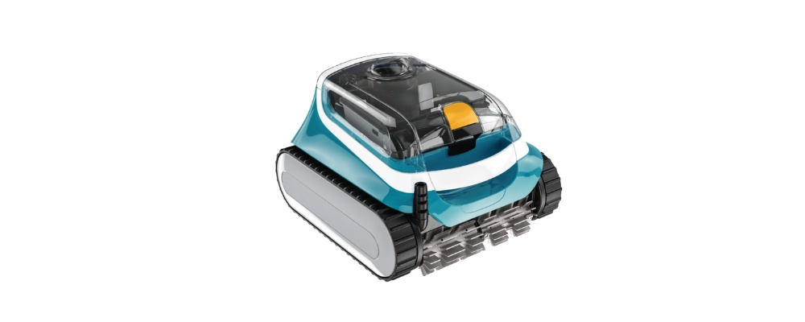

H3: 3. Zodiac RE4600iQ – Robotic cleaner with app control and full pool coverage
The Zodiac RE4600iQ is a high-end robotic pool cleaner designed for deep cleaning performance, with full floor-to-waterline coverage and remote control via the app.

H4: Coverage and Pool Compatibility
This device is designed to clean pool floors, walls, and the waterline. It is suitable for in-ground pools up to 12 × 6 m featuring an 18m cable. It is compatible with most pool shapes and all pool surfaces, including marbelite, fibreglass, and tiles.

H4: Filtration and Debris Handling
A dual-level filtration system with 150μ/60μ top access filter canisters that trap fine particles and larger debris like leaves. The transparent lid provides quick visibility.

H4: Key Features and Functionality
- SmartNav system with gyroscopic navigation
- iAquaLink™ app control for scheduling and remote operation
- Active dual-brush system for thorough scrubbing
- Easy-lift removal system for convenience
- Programmable cycles for energy-efficient cleaning

H4: Price Range & Warranty
Typically priced between R18,000 and R21,000 in South Africa. According to the product brochure, the device comes with a 2-year standard warranty with an additional 1-year warranty if paired with the iAqualink™ application.

H4: Where to Buy

Zodiac RE4600iQ is available for purchase via retailers including Zodiac, AC Direct and Online Pool Store.

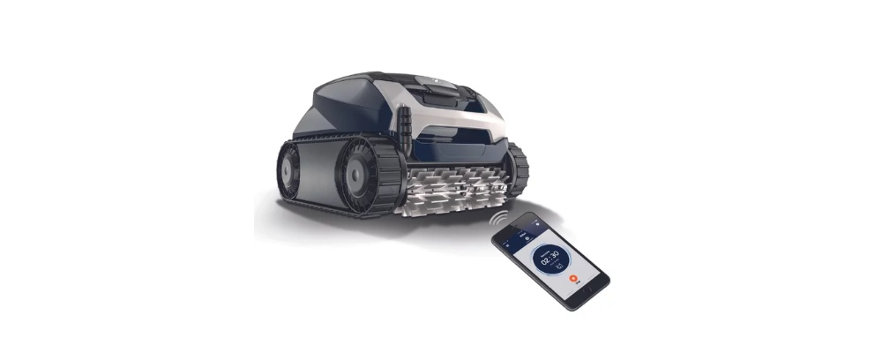

H3: 4. Zodiac ALPHA RA6700iQ – Advanced robotic cleaner with precision control and waterline scrubbing
The ALPHA RA6700 iQ is Zodiac’s most advanced robotic cleaner. It combines powerful performance, app-connected control, and complete pool coverage—including waterline cleaning.

H4: Coverage and Pool Compatibility
This device cleans the pool floor, walls, and waterline. It is ideal for in-ground and above-ground pools up to 15 × 7 m with rigid walls. It features a 21m cable. It is suitable for all common types of pool surfaces and shapes.

H4: Filtration and Debris Handling
Dual-layer (150μ/60μ micron) filters handle pick up large and small debris. The device can also be operated using single 60μ, 100μ and 200μ filters.
LED illuminated, easy-access filter canisters with a transparent lid for easy cleaning and maintenance.

H4: Key Features and Functionality
- Sensor Nav System™ 3.0 with advanced mapping
- iAquaLink™ app for full scheduling and monitoring
- Dual-motor system with active brushing
- Customisable cleaning cycles, including waterline-only mode
- Lift System™ for effortless removal from the water

H4: Price Range & Warranty
Generally priced between R22,000 and R26,000 in South Africa. According to the product brochure, the device comes with a 2-year warranty with an additional year if the robotic cleaner is connected with the iAqualink™ application.

H4: Where to Buy

The ALPHA RA6700 iQ is available for purchase via retailers, including Zodiac, as well as AC Direct and Online Pool Store.

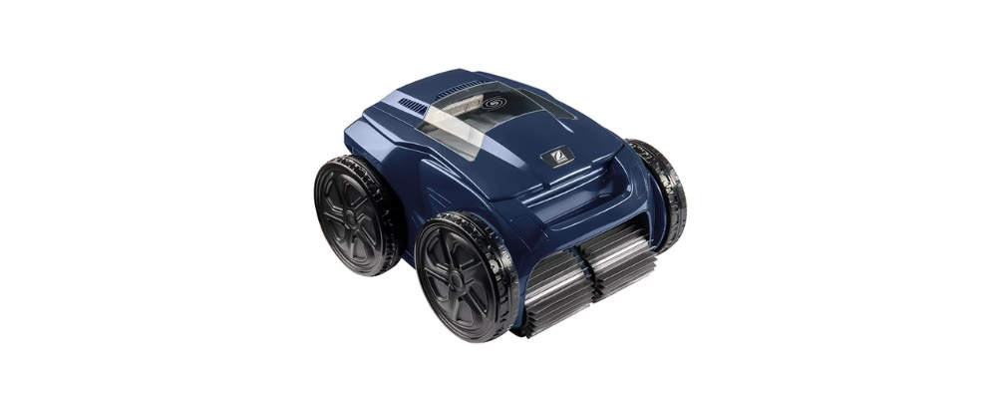

H3: 5. Zodiac CNX4090iQ – Smart robotic cleaner with Sensor Nav mapping, dual-stage filtration, and app control
The Zodiac CNX4090iQ is a premium robotic pool cleaner that delivers intelligent navigation, powerful cyclonic suction, and convenient app connectivity for easy operation.

H4: Coverage and Pool Compatibility
The CNX4090iQ is designed to clean pool floors, walls, and the waterline. It is suitable for in-ground pools up to 12 × 6 m, with an 18 m cable. It works on all common pool surfaces, including tiled, fibreglass, marbelite, and vinyl finishes.

H4: Filtration and Debris Handling
The cleaner uses a dual-stage filtration system (150 µ / 60 µ) to capture both large leaves and fine particles. A 4 L capacity basket and transparent filter window with LED lighting make it easy to monitor and empty.

H4: Key Features and Functionality
- Sensor Nav System™ that maps and plans the pool’s optimal cleaning path
- Powerful cyclonic suction technology for consistent debris pickup
- iAquaLink™ app control for scheduling, remote start/stop, and status updates
- Lift System™ for lighter, easier removal from the pool
- Compact 8 kg body with 150 W motor

H4: Price Range & Warranty
Typically priced between R18,000 and R22,000 in South Africa. Comes with a standard 2-year warranty.

H4: Where to buy

Available from Zodiac, Leroy Merlin, AC Direct, Online Pool Store, and other stockists.

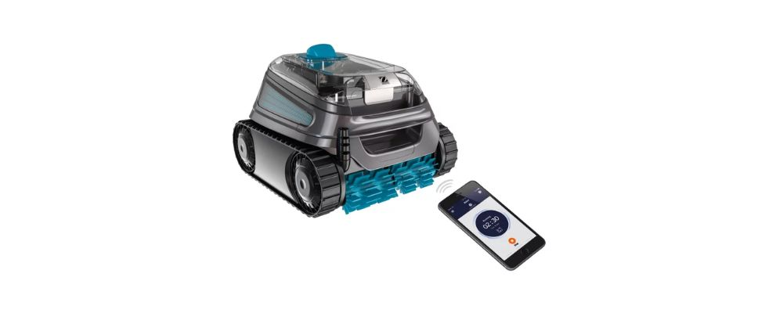

Category 2

H2: Best Suction Pool Cleaners in South Africa
Suction-side pool cleaners are a popular and cost-effective solution for keeping your pool clean using your existing pump and filtration system.

They’re easy to install, require minimal maintenance, and come in various designs to suit different pool shapes and surfaces.

In this section, we’ve rounded up some of the best suction pool cleaners available in South Africa—from reliable entry-level models to advanced options with geared navigation for improved wall coverage.

If you’re looking for an affordable and easy way to automate your pool cleaning, these top suction swimming pool cleaners are a great choice.

Linkreators 6-10

H3: 6. Baracuda Ranger – Simple, affordable suction cleaner for everyday use
The Baracuda Ranger is a pool cleaner that is easy to install and designed for reliable day-to-day floor cleaning in small to medium-sized residential pools.

H4: Coverage and Pool Compatibility
This suction pool cleaner is designed to clean pool floors only. It is suitable for in-ground and above-ground pools up to 9 × 5 m with flat or gently sloped floors.

H4: Filtration and Debris Handling
The Baracuda Ranger connects to your pool’s existing weir or suction port. Efficiently captures fine to medium debris like sand, insects, and small leaves via your pool’s filter system.

H4: Key Features and Functionality
- Diaphragm suction design with minimal moving parts
- Includes deflector wheel to prevent stalling on steps or corners
- Quiet operation for minimal disruption
- Easy to install with no tools required
- Durable disc for extended lifespan

H4: Price Range & Warranty
Typically priced between R1,900 and R2,600 in South Africa. Backed by a 2-year warranty.

H4: Where to Buy
Find a pool store that stocks Baracuda products near you using our interactive map. You can also purchase the Baracuda Ranger on Takealot.
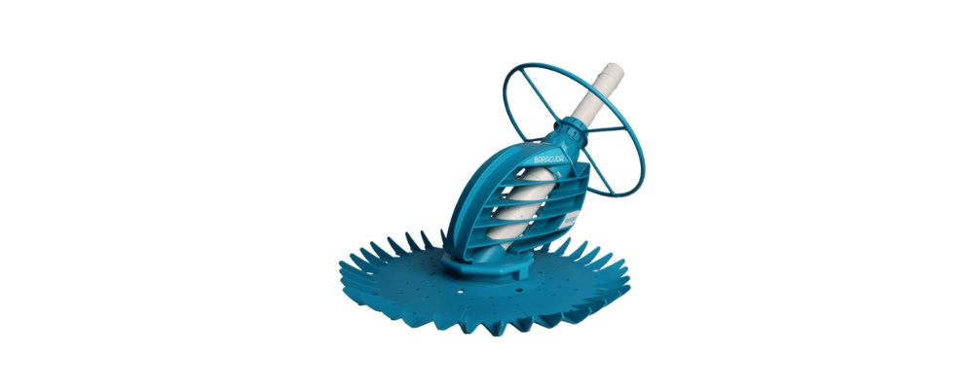

H3: 7. Baracuda Tracker – Suction cleaner with geared navigation and wall coverage
The Baracuda Tracker is a high-performance suction pool cleaner with geared navigation and scrubbing action for more thorough floor and wall cleaning.

H4: Coverage and Pool Compatibility
This device is designed to clean the pool floor and walls. It is ideal for in-ground pools up to 10 × 5 m and suitable for most surface types, including marbelite, fibreglass, and vinyl.

H4: Filtration and Debris Handling
The Baracuda Tracker connects to your existing suction line and uses your pool’s filtration system. It is suitable for handling fine and large debris efficiently through a twist-and-lock hose system.

H4: Key Features and Functionality
- X-Drive Technology for patterned cleaning paths
- Dual scrubbers for enhanced surface cleaning
- Twist-and-lock hose for secure suction and flow
- Climbs walls and navigates around obstacles
- Compatible with variable-speed and energy-efficient pumps

H4: Price Range & Warranty
Typically priced between R3000 and R4,000 in South Africa. Includes a 2-year warranty.

H4: Where to Buy
Find a pool store that stocks Baracuda products near you using our interactive map. You can also purchase the Baracuda Tracker on Takealot.
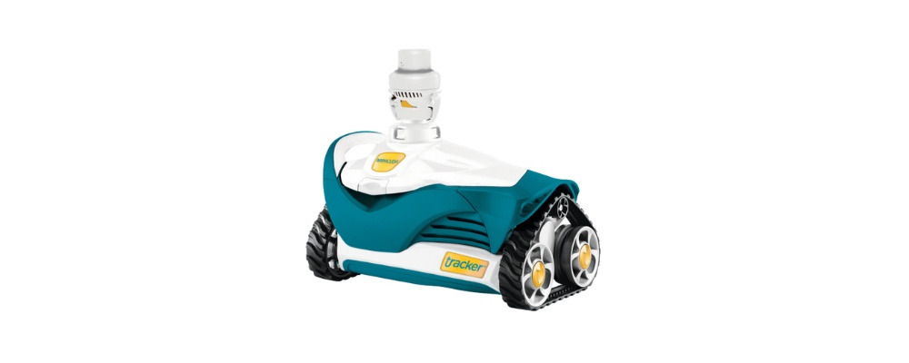

H3: 8. Zodiac Pacer - Classic suction cleaner built for simple, reliable floor cleaning
The Zodiac Pacer is a trusted entry-level suction pool cleaner with a proven track record for durability, ease of use, and effective floor cleaning in small to medium pools.

H4: Coverage and Pool Compatibility
This device cleans pool floors and walls only. Suitable for in-ground or above-ground pools up to 9 × 5 m and all pool surfaces.

H4: Filtration and Debris Handling
The Zodiac Pacer connects directly to the pool’s suction line and uses the existing filtration system. Efficiently handles small to medium debris such as sand, dust, and small leaves.

H4: Key Features and Functionality
- Classic disc-style cleaner with minimal moving parts
- Proven diaphragm technology for consistent suction
- Quiet, smooth operation with low wear and tear
- Quick to install with no tools required
- Lightweight design for easy handling

H4: Price Range & Warranty
Typically priced between R1,800 and R2,400 in South Africa. Backed by a 2-year manufacturing defects warranty.

H4: Where to buy
The Zodiac Pacer is available for purchase via retailers including Zodiac, The Pool Team and Takealot.



H3: 9. Gemini Pool Cleaner - Twin-diaphragm suction cleaner for improved debris handling
The Gemini is a budget-friendly suction pool cleaner with dual diaphragm technology to deliver strong suction, reliable movement, and improved cleaning efficiency across floors and walls.

H4: Coverage and Pool Compatibility
This device cleans the pool floor and walls. Suitable for in-ground pools up to 10 × 5 m and works effectively on most surfaces, including fibreglass, marbelite, and vinyl.

H4: Filtration and Debris Handling
The Gemini connects to the pool’s existing filtration system. Handles a wide range of debris sizes—from fine sand to larger leaves—using its powerful twin-diaphragm design.

H4: Key Features and Functionality
- Twin diaphragms for uninterrupted suction flow
- Designed to reduce clogging and loss of power
- Wide disc for better floor coverage
- Climbs walls and navigates most corners
- The combi pack includes hoses and connectors

H4: Price Range & Warranty
Typically priced between R1,300 and R2,000 in South Africa. Comes with a 2-year limited warranty.

H4: Where to buy

The Gemini pool cleaner is available from retailers including Pool Xpert, The Pool Team, Takealot and Swemgat.

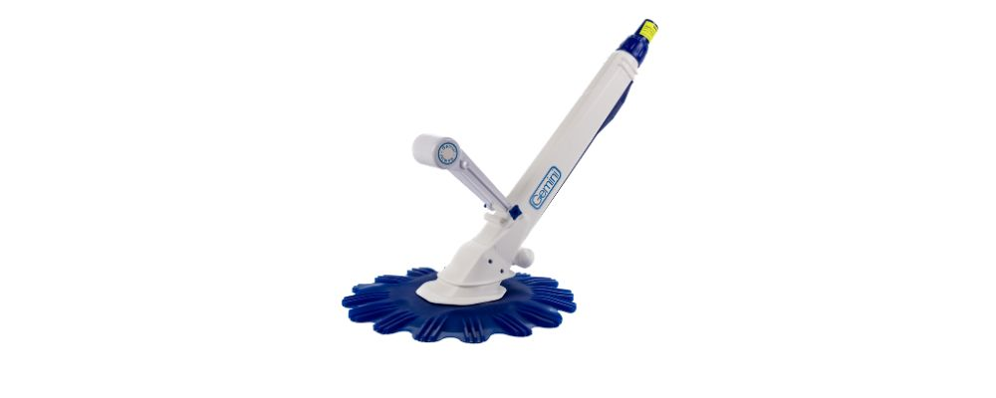

H3: 10. Zodiac AX20 Activ - Suction cleaner with geared navigation and active scrubbing
The Zodiac AX20 Active is a high-performance suction pool cleaner that combines intelligent navigation with powerful scrubbing for efficient cleaning of pool floors and walls.

H4: Coverage and Pool Compatibility
This device cleans the pool floor and walls. Ideal for in-ground residential pools up to 10 × 5 m, and compatible with most surfaces including fibreglass, marbelite, and vinyl.

H4: Filtration and Debris Handling
Connects to your pool’s weir or dedicated suction line and uses your filtration system. Efficiently captures fine dust, sand, and large debris via twist-and-lock hose for consistent flow.

H4: Key Features and Functionality
- X-Drive Navigation for smart, patterned cleaning
- Dual scrubbers for lifting stubborn dirt and algae
- Climbs walls with ease for a deeper clean
- Twist-and-lock hose for secure suction and less power loss
- Compatible with variable-speed and energy-efficient pumps

H4: Price Range & Warranty
Generally priced between R4,400 and R5,000 in South Africa. Includes a 2-year limited warranty.

H4: Where to buy
The Zodiac AX20 Activ is available from retailers including Zodiac, The Pool Team, and Takealot.

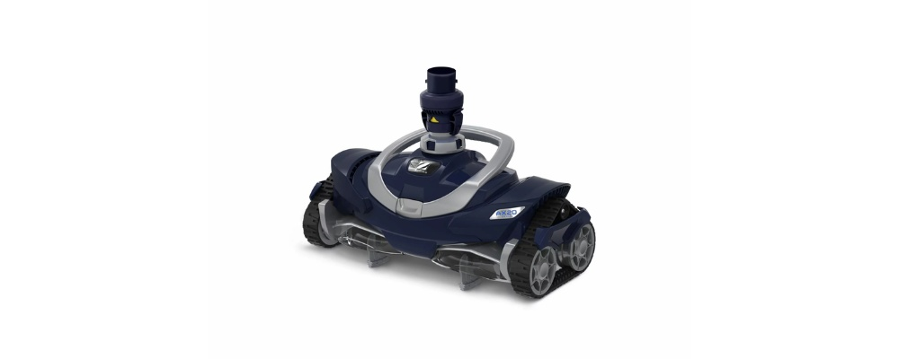

H3: 11. BLU52 Navigator – Reliable suction cleaner with diaphragm drive and swing-arm mobility
The BLU52 Navigator is a no-frills, efficient suction cleaner built for everyday residential pools. It uses durable diaphragm technology and a swinging float arm to keep moving steadily through different pool layouts.

H4: Coverage and Pool Compatibility
This unit cleans pool floors and some mild slopes; it’s best for pools without too many obstacles. The swinging float arm helps it navigate more effectively than static cleaners.

H4: Filtration and Debris Handling
The Navigator uses a diaphragm drive, a reliable suction mechanism that maintains steady power for effective debris pickup. It easily vacuums up fine dirt and small leaves, sending them through the hose to your pool’s filtration system for collection.

H4: Key Features and Functionality
- The swinging float arm improves navigation and prevents the cleaner from getting stuck in corners.
- Quiet, energy-efficient operation powered by your pool’s existing pump.
- Durable diaphragm drive with fewer moving parts for simple, reliable performance.
- Low-maintenance design with easy access to internal components for cleaning or replacement.

H4: Price Range & Warranty
The BLU52 Navigator typically retails between R 999 and R 2,999 in South Africa, depending on the retailer and package type (standard unit vs. combi pack). Comes with a standard 2-year warranty.

H4: Where to buy
The BLU52 Navigator is available via distributors including Checkers Hyper, Leroy Merlin, and more. It is also available on Takealot.

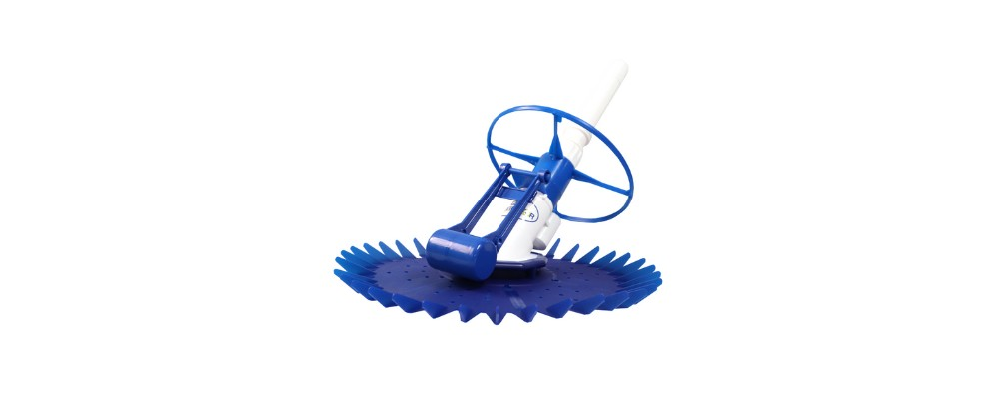

Optional value-add section

* H2: What is the best automatic pool cleaner in South Africa?

The best automatic pool cleaner for your pool depends on factors like pool size, surface finish, budget, and how hands-off you want to be.

For robotic models, the Baracuda XA4030 iQ and Zodiac ALPHA RA6700iQ offer full floor, wall, and waterline coverage with app control and dual-level filtration—ideal for larger pools and users wanting advanced features.

The Zodiac CNX4090iQ is also a strong option for those looking for cordless convenience with robust cleaning power.

On the suction side, the Zodiac AX20 Activ and Baracuda Tracker stand out for their geared navigation, wall-climbing ability, and scrubbing performance.

Budget-conscious buyers may also find excellent value in the Gemini or Zodiac Pacer, which offer reliable floor and wall cleaning at lower price points.

Need help finding an automatic pool cleaner that suits your cleaning needs? Contact us for expert advice.

summary/conclusion

H2: Final Thoughts on The Best Automatic Pool Cleaners in South Africa
Ready to make pool cleaning easier with an automatic pool cleaner?
Browse our full range of automatic pool cleaners, including robotic pool cleaners or suction pool cleaners. Then, use our interactive map to find a pool store that stocks Baracuda products near you.
Still considering your options and trying to make the right decision? Here are a few tips:
- Start by assessing your pool’s specific requirements. Consider factors such as pool size, surface finish, shape, debris load, and filtration setup. Also, think about whether you prefer a fully automated system or one that works in tandem with your existing pool pump and filter.
- Robotic cleaners are ideal for larger or heavily used pools, offering superior cleaning performance, independent operation, and smart features like programmable cycles and app control.
- Suction cleaners, on the other hand, are well-suited to smaller pools with lighter debris and offer a more budget-friendly, low-maintenance solution.
This related article covers how to choose the right automatic pool cleaner, where we unpack key considerations fully. On our blog, we also cover guides that cover everything you need to know about suction pool cleaners, weekly pool maintenance, tips for maintaining pool equipment during loadshedding, and more - ideal for pool owners.
You can also contact us to get personalised advice from experts on our team.

